***Measure Carbon emission of the application – Case study***

**Team mentor:** Mr. Dhilip Kumar

**Team members:** Shagun Singh

Sahil Sobhani

Jasraj Singh Juneja

Aditya Joshi

Shreyansh Rai

**Problem statement description:**

The software, applications, and tools are developed to address and assist the business problem. The engineering team develops software and handles Nonfunctional duties, such as exception management, logging, and tracing, in addition to choosing the best resource to execute and support business operations. There is currently no method for measuring or monitoring code to optimize the carbon footprint.

*Assumptions/callouts -* This could be framework or tool to monitor carbon emission for a specific language for Java or Python

*Expected outcome -* Create a tool which can measure the code and recommend the optimized way to control the carbon emission.

*Tools and technologies used –* Python and React JavaScript

**Solution – “Code for Earth”**

**CodeForEarth** is a carbon emission calculator for the applications which also provides with reduction and optimization solutions. The vision of the product is to **take a step towards a sustainable future.** A platform where you not only just calculate the environmental impact but also see the breakdown and learn what measures can be taken to improve it.

**Introduction**

* 1. **Concept of carbon footprint**

Carbon footprint is amount of carbon dioxide (CO2) emissions associated with all the activities of a person or other entity. It includes direct emissions, such as those that result from fossil-fuel combustion in manufacturing, heating, and transportation, as well as emissions required to produce the electricity associated with goods and services consumed.



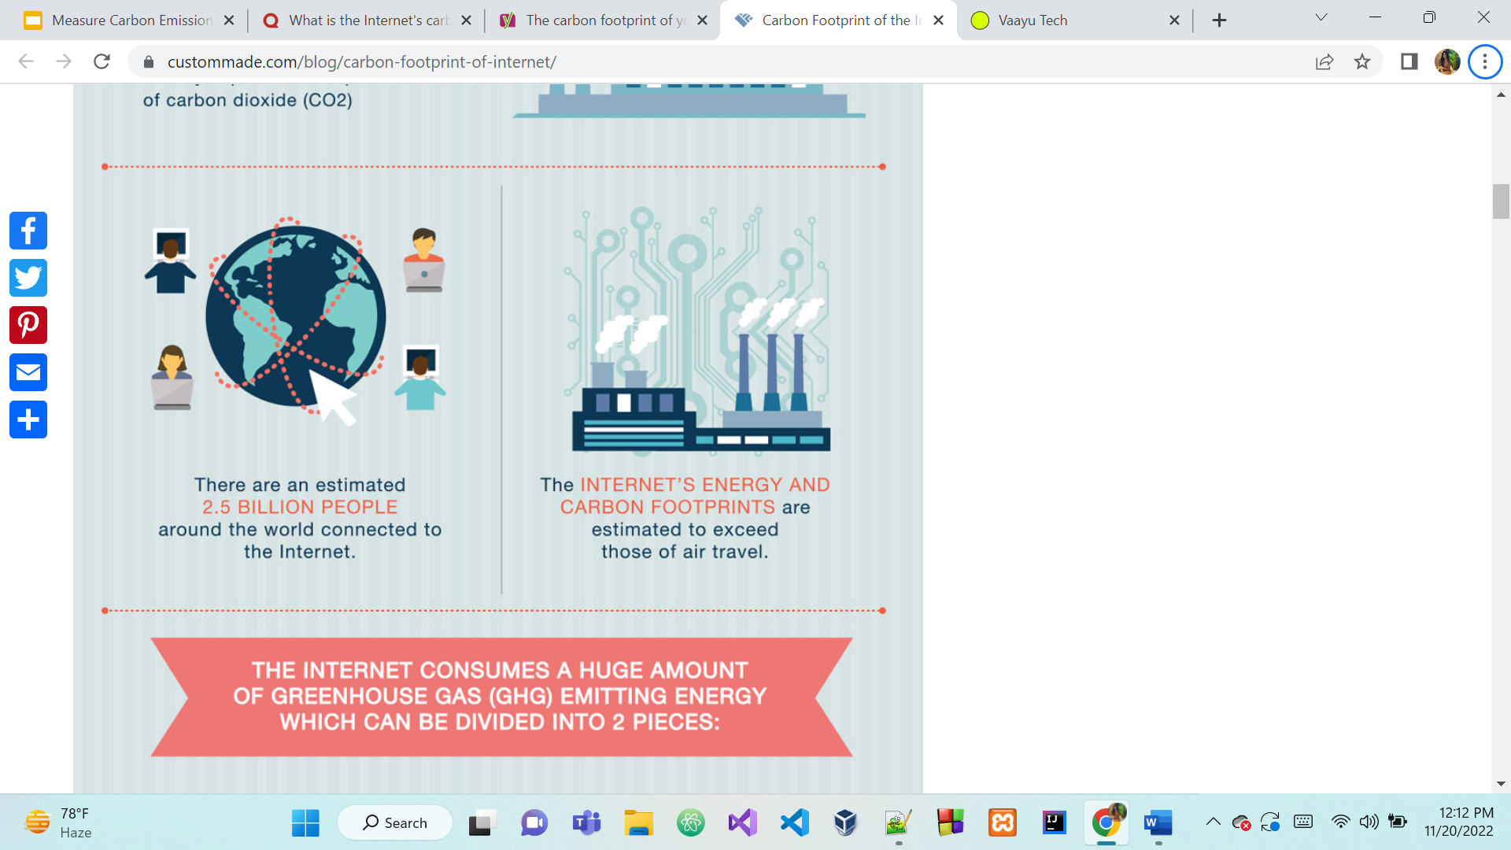

* 1. **Calculation of carbon emission of the application**

*Carbon dioxide equivalent*

* To understand how carbon emission works , we stumbled upon Co2-eq which stands for Carbon-dioxide equivalent
* We find out the Co2-eq of our code to figure out the total carbon footprint of our code
* The quantity of CO2 that would have the same global warming effect is a standardized way to represent the global warming potential of different greenhouse gases.
* Carbon emissions are calculated in kilos of CO2-equivalent per kilowatt-hour for computation, which produces CO2 through the electricity it uses.

*Carbon dioxide  emissions are the result of two main factors:*

* Carbon intensity = Carbon Intensity of the electricity consumed for computation: quantified as kg of CO₂ emitted per kilowatt-hour of electricity.
* Power  = Power Consumed by the computational infrastructure: quantified as kilowatt-hours.
* Total Co2eq = power * carbon intensity

|  |  |
| --- | --- |
| Energy source | Intensity  Kg/Mwh |
| Coal | 995 |
| Petroleum | 816 |
| Natural Gas | 743 |
| Geothermal | 38 |
| Wind | 26 |
| Hydro | 26 |
| Nuclear | 29 |
| Solar | 48 |

1. We initially find out the country’s power supply mix
2. We multiply the percentages with the values given in the table

If the energy mix of the country is not available , we consider the world average of about 470 g Co2eq/KwH

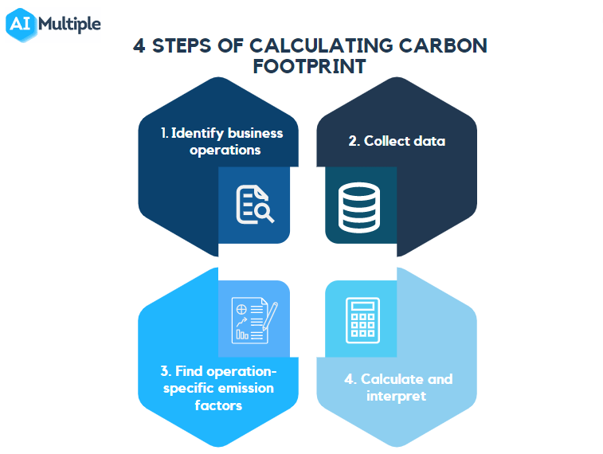

**1.3 Purpose**

Our purpose of a carbon measurement assessment is to establish the baseline understanding of an organization’s impact on climate. With AI models becoming more ubiquitous and deployed across different sectors and industries, AI’s environmental impact is also growing. For this reason, it is important to estimate and curtail both the energy used and the emissions produced by training and deploying AI models. This package enables developers to track carbon dioxide (CO₂) emissions across machine learning experiments or other programs.

This package enables developers to track emissions, measured as kilograms of CO₂-equivalents (CO₂eq) in order to estimate the carbon footprint of their work. For this purpose, we use CO₂-equivalents [CO₂eq], which is a standardized measure used to express the global warming potential of various greenhouse gases: the amount of CO₂ that would have the equivalent global warming impact. For computing, which emits CO₂ via the electricity it is consuming, carbon emissions are measured in kilograms of CO₂-equivalent per kilowatt-hour.

**Reduction of carbon emission**

**2.1 Need for reduction of carbon emission**

The internet consumes a lot of electricity. 416.2TWh per year to be precise. To give you some perspective, that's more than the entire United Kingdom.

From data centers to transmission networks to the billions of connected devices that we hold in our hands, it is all consuming electricity, and in turn producing carbon emissions equal to or greater than the entire air travel industry.

Such massive usage of the internet suggests that we may have progressed towards a greener society by significantly reducing the usage of paper, and consuming information online. However, this doesn’t mean that we’ve become carbon neutral. The energy required to support the constant usage of electronic gadgets is significantly adding to environmental pollution in the form of e-junk.

**2.2 Ways of reducing carbon emissions**

### **Boost your site's speed**

The most important aspect to take into account when building your green website is your site's speed. The least amount of time users spend waiting for your site to load, the least amount of energy and carbon emissions that is used.

*Caching solution* – caching implies temporarily storing a duplicate of a website’s original content (static resources) on the user’s device. This greatly decreases server energy usage and improves page load times;

*Lazy loading* – load only the needed resources at the time and delaying the remainder till the user requests. It’s an optimization method for minimizing data use;

*AMP (Accelerated Mobile Pages)* – provides an original webpage with a minimalist, stripped-down mobile version. This technology makes mobile content load quicker by removing unnecessary code and file size;

*Lightweight fonts* – decrease custom and personalized fonts which often add up to overall page size. The interesting alternative could be system or web-safe fonts.

### **Use green web hosting**

Data-centers are one of the greatest damaging factors when it comes to climate change as they require an extensive amount of energy to keep all the data they hold. One of the first things to consider when moving towards nonpolluting alternatives is the type of hosting we will use.

### **Optimization of websites multimedia content**

Images are the most significant contributor to a page’s weight for most websites. The more images we use and the larger those image files are, the more data is transferred, and the more energy is used in the process. However, it’s crucial to always ensure that your image size is optimized and loads more effectively:

*Vector graphics* – utilize CSS and vector graphics to create an experience with considerably lower resources than standard pictures like JPEGs or PNGs;

*Compressing images* – reduce file sizes of images on your size without proportion changes. It’s recommended to use lossy compression (bigger reduction with little loss in quality) for most sites;

*Reduce video* – decrease the amount of video on your site if you can, or make the material shorter. It places a significantly larger demand on the user’s CPU.

*No auto-play* – the users will start the video if it’s in their interest. Additionally, auto-play might be annoying and decrease user experience. Avoiding this is better.

* **Work on your SEO**

Although SEO may appear to have nothing to do with website efficiency, it’s closely tied to lower energy usage. Better internet search results can lead to **cutting bounce rates and reducing visits to the pages that don’t fit your user’s demands.** Copywriting, just like search engine optimization, also influences website efficiency. Make sure we structure our content with the right keywords and headlines, make it mobile-first and provide the most relevant information in a prominent place.

### **Keep code clean**

Tidy and simplified code is a good thing in general. By creating efficient queries and using the right existing frameworks and libraries, we can efficiently provide the features we want. Another good practice for reducing carbon dioxide equivalent is to use less [JavaScript](https://applover.com/blog/tag/javascript/), as it adds extra weight to the web and increases the amount of processing. When using a CMS (Content Management System), remove unnecessary plugins that only make the site heavier.

### **Reduce tracking and advertising script**

Tracking and advertising scripts hardly provide any benefit to the user and typically can significantly increase file sizes or slow websites down. Moreover, trackers can cause loading the page even twice as long. By decreasing monitoring scripts, which data often invade user’s privacy, we could also reduce annual CO2.

### **Consider a PWA solution**

[Progressive Web Application](https://applover.com/blog/tag/progressive-web-app/) (PWA) is a web-based application built to run on any platform, including desktop and mobile devices. The main advantage of this solution is that it cancache files on the user’s device. This can dramatically minimize the amount of data loaded. Many companies decided to develop a PWA.

### **Block bots to reduce unnecessary non-human traffic to your site**

As we mentioned above, bot traffic accounts for much internet traffic. Identify bots that are not valuable to us and block them from entering our site. If they request our server but tell our server not to answer them, we’re saving energy. we can block bad bots by looking at our server log for unusual behaviors and blocking the individual or the entire range of IPs where unusual traffic comes from. An alternative is to use a bot management solution from providers like Cloudflare. For the ‘good’ bots, we can determine whether they bring value to your site or not. If the answer is no, don’t hesitate to block them.

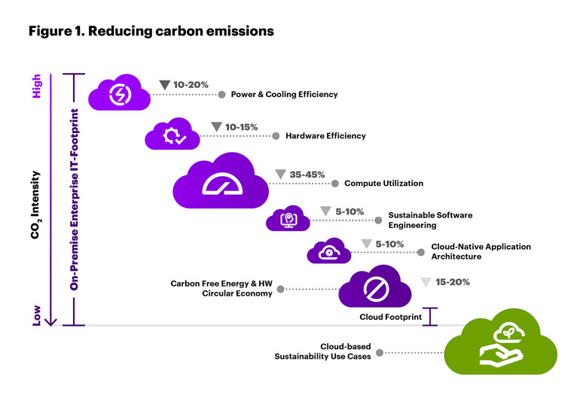

**Optimization**

Simple and efficient code with the smallest possible number of lines is more carbon-efficient, emitting the least possible CO2. Software with too many unnecessary lines, sometimes referred to as ‘bloatware,’ takes up more space and requires more processing time, which emits more CO2.

Developers should aim for the smallest amount of functions to perform a task, as this is the most cost and climate efficient. Developers can use a tool called ‘Big O notation’ to calculate the efficiency of algorithms. This notation is used to view the worst-case scenario of an algorithm, showing the execution time and space used. This is important best practice for algorithms operating at scale, helping create the most efficient algorithms that, in turn, emit the least possible CO2.

**Perform the following optimizations on your code to reduce the resources it consume.**

* 1. **Optimizations in loop**
* **Unroll small loops**: Most of the times Compiler does this automatically, but it is a good habit of writing optimized codes. Matrix updations using this is very advantageous.
* **Avoid calculations in loop**: We should avoid any calculation which is more or less constant in value. Inner loops should have minimum possible calculations.
* **Avoid pointer Dereference in loop**: Pointer dereferencing creates lots of trouble in memory. So better assign it to some temporary variable and then use that temporary variable in the loop.
* **Use Register variables as counters of inner loops**: Variables stored in registers can be accessed much faster than variables stored in memory.
  1. **Fast Mathematics**
* **Avoid unnecessary Integer Division**: Division operations are slow so we should minimize the division operations.
* **Simplifying Expressions**: Sometimes we can reduce some operations by simplifying expressions.
  1. **Optimizations with switch statement**
* Compilers translate switch statements in different ways. If case labels are small contiguous integer values, then it creates a jump table. This is very fast and doesn’t depend on the number of case labels also. If case labels are longer and not contiguous then it creates comparison tree i.e. if…else statements. So, in this case, we should keep the most frequent label first and the least frequent label should be at last.

* 1. **Prefer int to char or short**
* We should always prefer int to char because C performs all operations of char with an integer. In all operations like passing char to a function or an arithmetic operation, **first char will be converted into integer and after compilation of operation, it will again be converted into char.** For a single char, this may not affect the efficiency but suppose the same operation is performed 100 times in a loop then it can decrease the efficiency of the program.
  1. **Prefer pre Increment/Decrement to post Increment/Decrement**
* In pre-increment, it first increments the value and just copies the value to variable location but in post-increment, it first copies the value to a temporary variable, increments it and then copies the value to the variable location. If post-increment is 1000 times in a loop it will decrement the efficiency.
  1. **Order of expression**

**A || B**

* Here first A will be evaluated, if it’s true then there is no need of evaluation of expression B. So We should prefer to have an expression which evaluates to true most of the times, at the A’s place.

**A && B**

* Here first A will be evaluated, if it’s false then there is no need of evaluation of expression B. So We should prefer to have an expression which evaluates to false most of the times, at the A’s place.

**Agile Methodology**

**4.1 Why not the traditional waterfall methodology:**

A software methodology that needs to know all requirements up-front and also requires design documents months before any coding begins may seem suspect these days. But in the 70s and 80s, when the main source of money to be made in software was in the civil engineering, defense and aerospace industries, the planning was everything.

Waterfall method was based on the fact that stakeholder sign-off for a requirement or design document meant that the stakeholder would see a software system sometime later that accurately reflected all of those plans.

**4.2 Inception of Agile Methodology:**

Waterfall projects began to fail due to an imbalance between a well-intentioned methodology and the typical outcome for large-scale software projects.

Agile was developed as a solution for the shortcomings of the waterfall model. This method combines iterative and incremental approaches and encourages a flexible environment.

**Iterative development:** An iterative process is one that makes progress through successive refinement. Since customer requirements are not clear, every iteration incorporates feedback at multiple levels in the product development process.

**Incremental development:** An incremental process is one in which software is built and delivered in a staggered approach. Each piece, or increment, represents a complete subset of functionality. Each increment is fully coded and tested and it is potentially shippable.

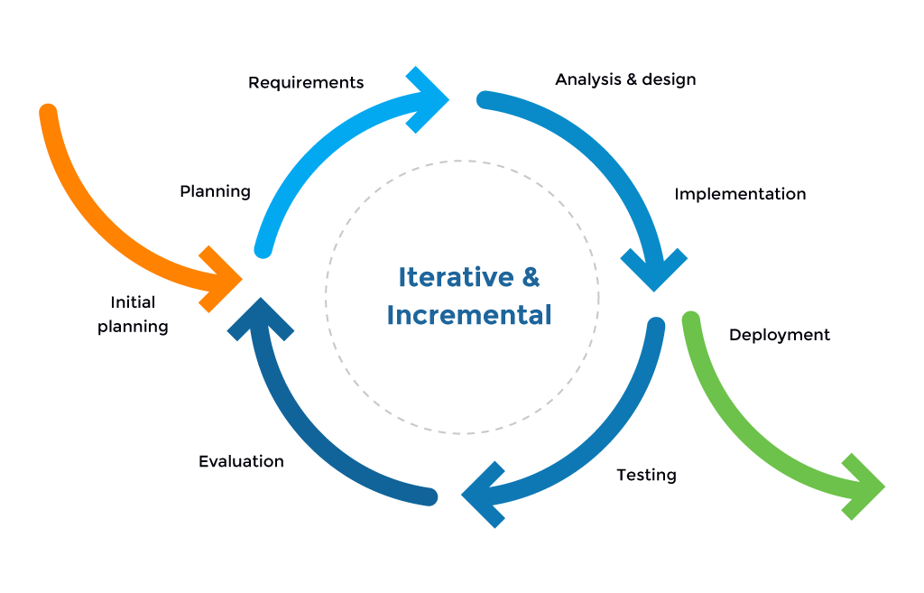

Iterative and Incremental development model

**The Manifesto for Agile Software Development**

The manifesto proclaimed that they value

* ***Individuals and interactions****over processes and tools*
* ***Working Software****over comprehensive documentation*
* ***Customer collaboration****over contract negotiation*
* ***Responding to Change****over following a plan*

This Agile Manifesto — led to a fundamental change in how software is developed and projects are managed.

**76% of users choosing an enterprise Agile planning tool do so to increase their projects’ visibility.**

**Implementation of Agile Methodology at CodeForEarth:**

We’ll be taking a deeper dive into how our team uses an incremental and iterative approach to develop the features. One of the Agile methodologies, the Scrum Framework could be followed.

**4.3 Scrum**

This is a lightweight framework employed in the development of complex products since the early 1990s.

The **Scrum framework** is characterized by overlapping phases, i.e. you work on one feature at a time and conduct all the phases of development such as analysis, design, implementation, and testing and then product a potentially shippable product increment.

**Scrum Team:**

*The scrum team consists of three players:*

* **Product Owner**: Creates product backlog, prioritizes the backlog and is responsible for the delivery of the functionality at each iteration. Major decision power lies with the Product Owner and he/she looks forward to maximize the ROI.
* **Scrum Master**: Responsible for facilitating and coaching the team. Organizes Scrum events like daily stand-ups, Sprint reviews and retrospectives. During the Sprint, Scrum Master is responsible for removing any impediments.
* **Development Team:**This is self organizing team and manages its own work and organizes the work to complete the sprint or cycle

In “Scrum”, the development is done in**sprints** and each feature is broken down into “**Epics**” which are further broken down into “**User Stories”.**

These three roles together constitute the Scrum Team.

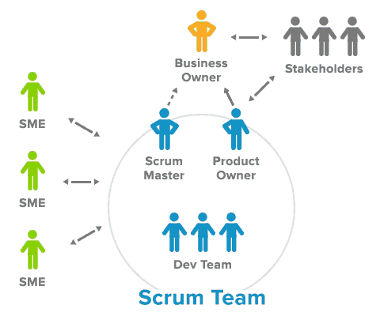

**A Typical Scrum:**

1. **Team Size**: The scrum team would comprise of 5 members.
2. **Sprint duration**: Sprint meeting in every 3 days
3. **Spring backlog**: Contains user stories that are taken from the Product Backlogorder of priority. These are further divided into tasks.

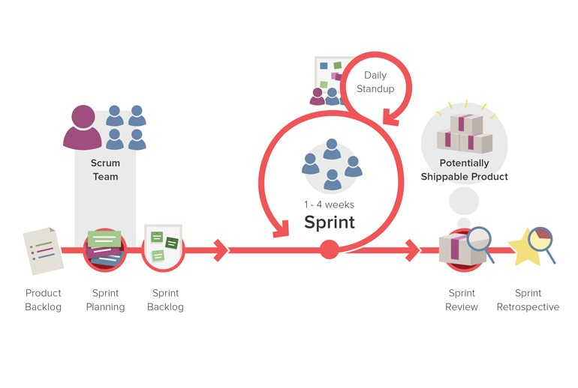

Let us look at a scenario where our team has decided to build the following features.

**Feature list —**

* 1. Methodology of emission calculation
  2. Carbon emission calculator
  3. Reduction of carbon emission
  4. Share user experience

Each feature goes through the following phases:

1. Ideation
2. Design
3. Implementation
4. Testing
5. Deployment

Let’s see how it is implemented at **Code for Earth** for the feature list taken.

**3.3.1 Ideation –** The emission calculator is a lightweight easy to use python pip package. Here, emissions are tracked based on user’s power consumption and location dependent carbon intensity. At first, the user should be able to download the package, then there will be a small instruction manual which the end user can follow to make the process easier and smooth. User will then embedded their code and then run the code and let CodeforEarth calculate. The output will comprise of CPU usage percentage and GPU power as well as the time taken by the code. User will then enter all of these parameters in the calculator which will further calculate the carbon emission of the code. User should be able to visualize the output in clear dashboards.

**3.3.2** **Design** - the goal is to make interactive, user-friendly UI. Design should be simple and precise. The website will consist of a home page which will firstly answer all the basic questions of the customer such as what carbon emission is, why is carbon emission, what is the need of reduction, how to reduce carbon emission, methodology of calculation. We’ll also have a section where user can share their feedback and their experience to spread awareness and take a step forward towards a sustainable environment and a green web. The visual layout of the calculator will be simple and direct and will ask multiple inputs from the user to calculate.

**3.3.3 Implementation and testing**- Once the design is finalized, developers will build the features related to various screens and QA team will go ahead with testing.

**3.3.5 Deployment** - Once all the functionality is tested the product will be deployed and the customer will be asked to share their experience to spread awareness.

**Summary**

Agile methodology ensures great product quality, higher customer satisfaction, increased ROI. As all the phases are done during the same iteration, there are regular feedbacks, which can be incorporated into the subsequent increments.

Most importantly, every iteration has an increment developed that is potentially shippable which means it is fully functional. This gives the customer as to where the product status is and what exactly is the progress. Each of these increments is produced in a staggered manner. Agile methodologies help product managers to improve their products continuously.

**Screenshots of frond end**

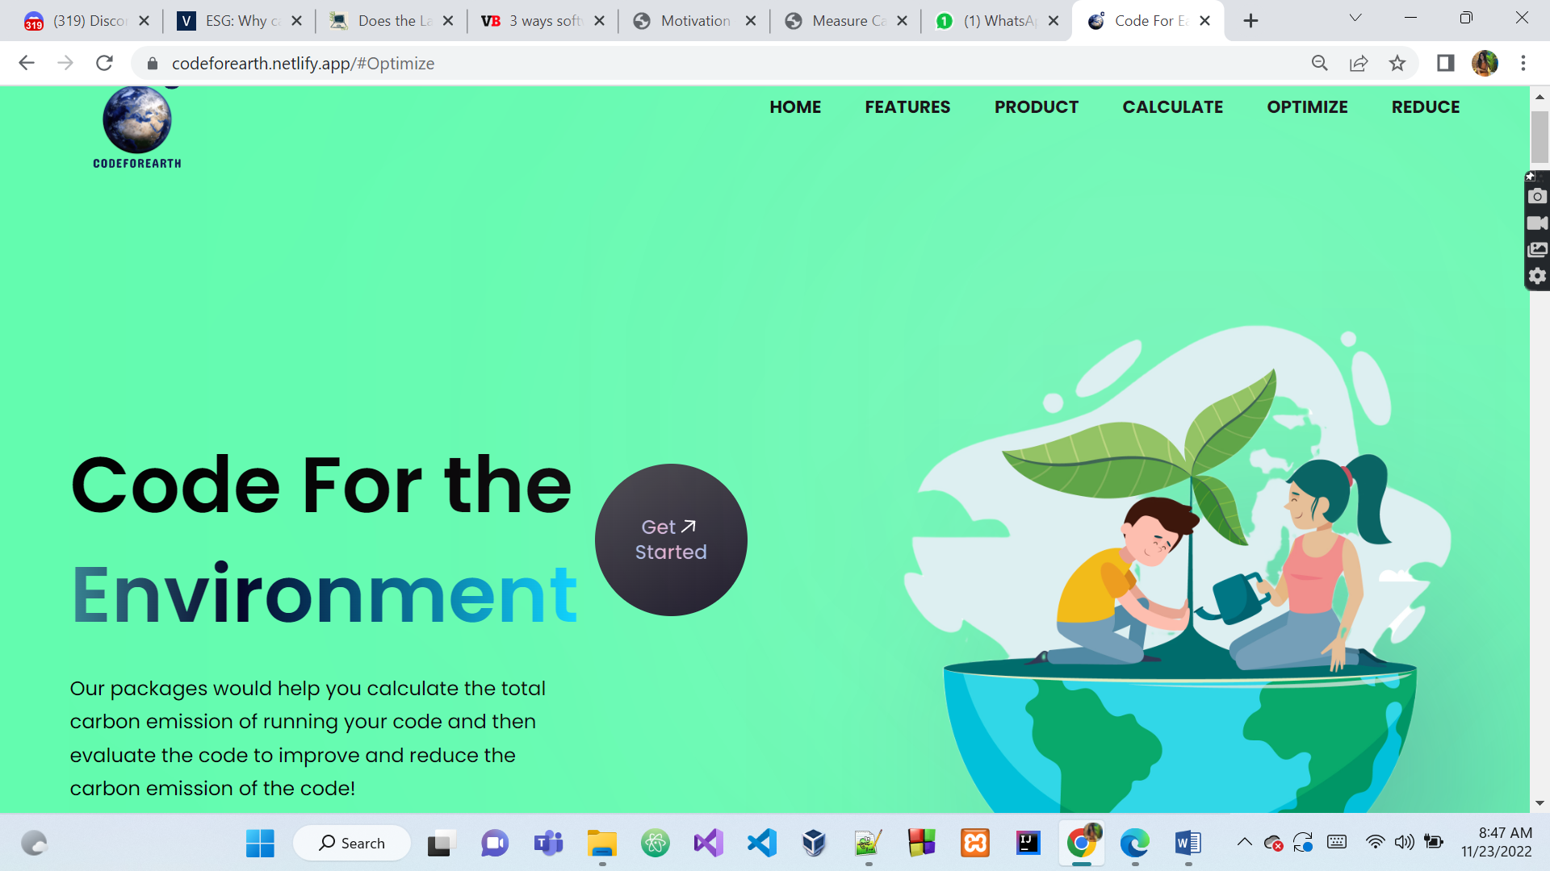

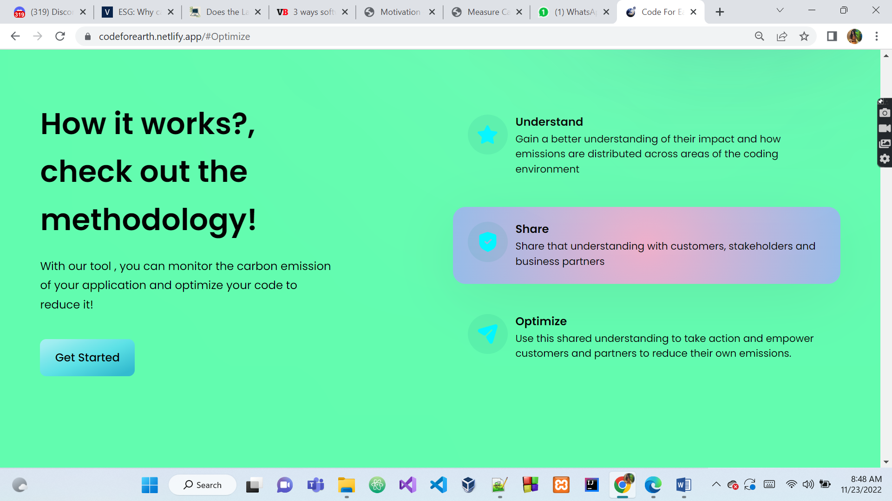

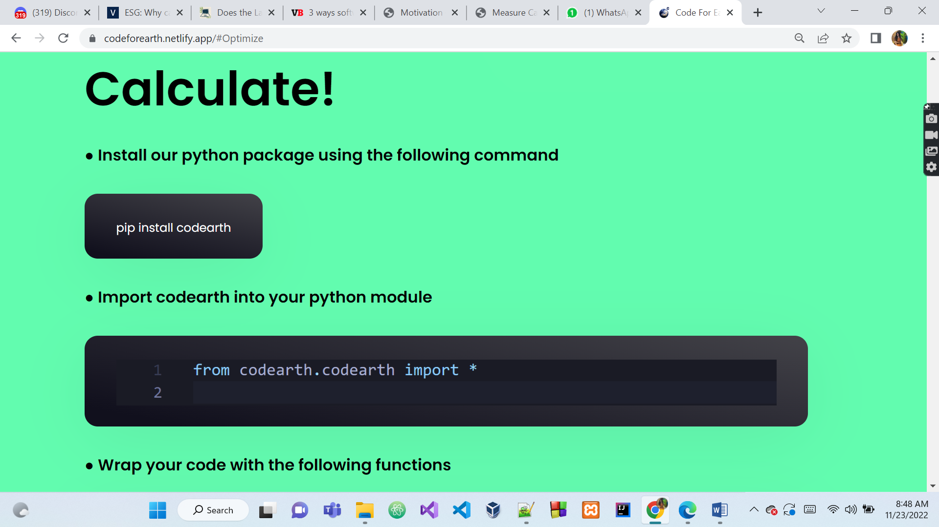



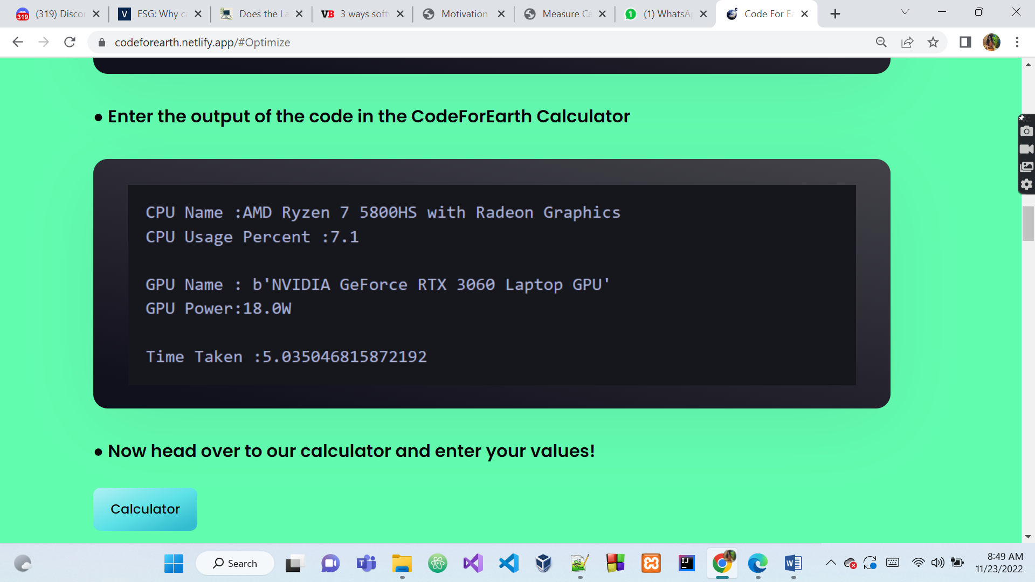

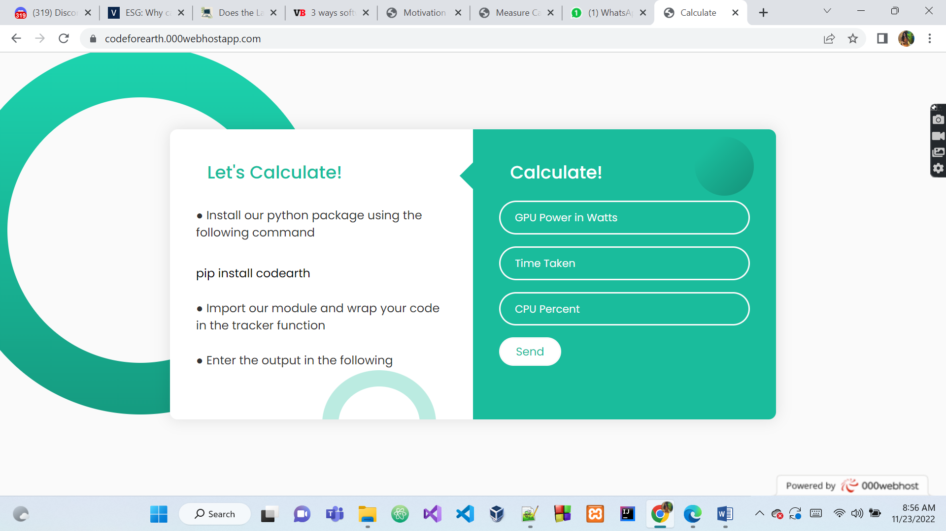

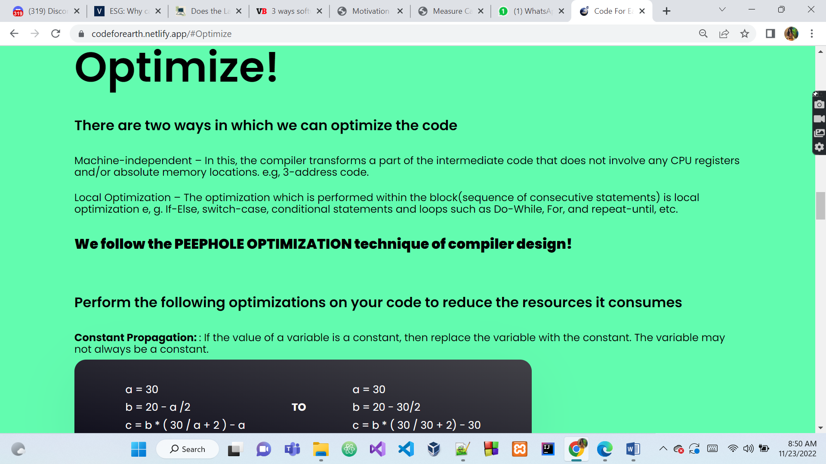

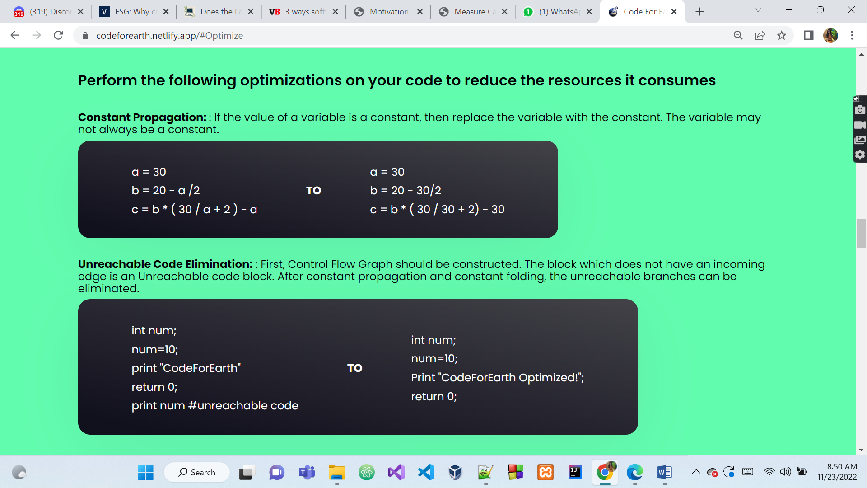

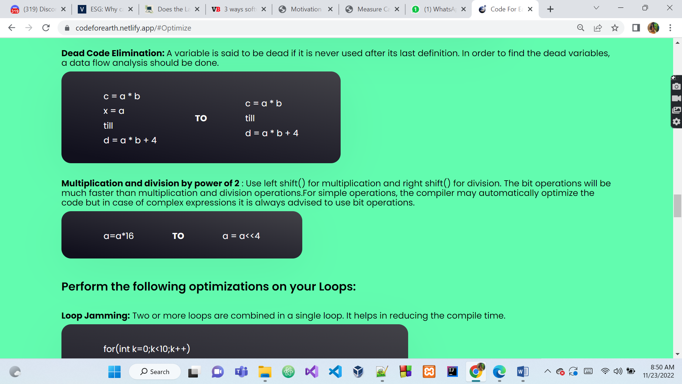

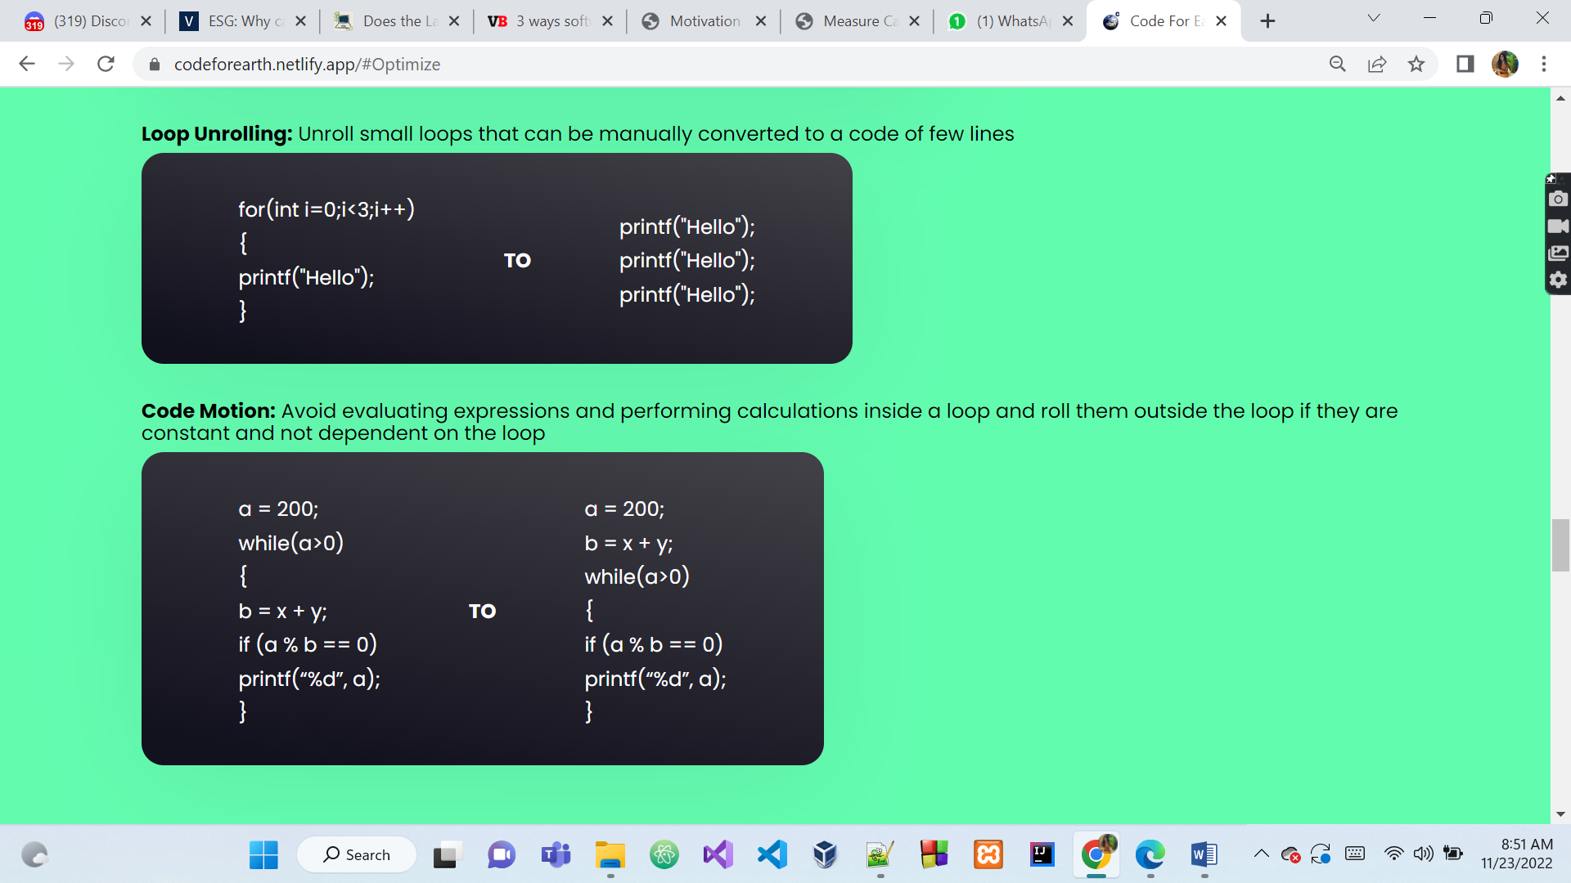

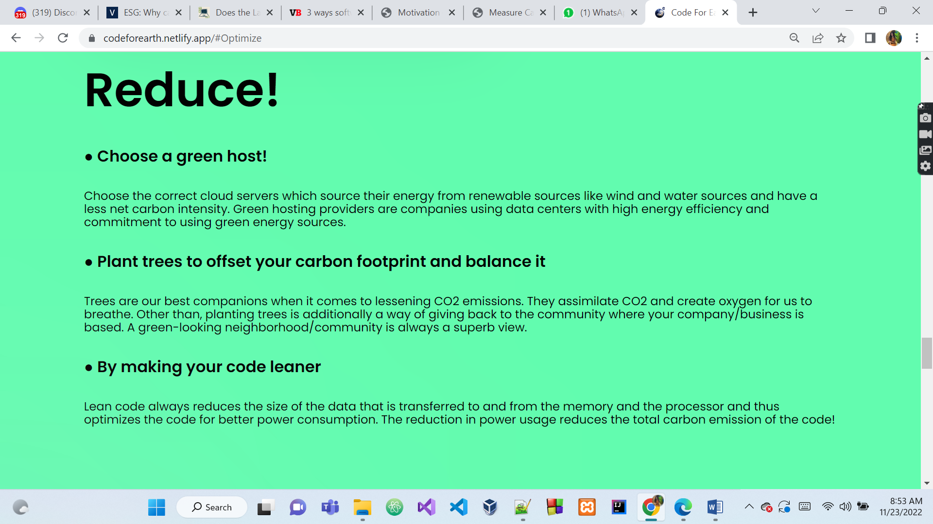

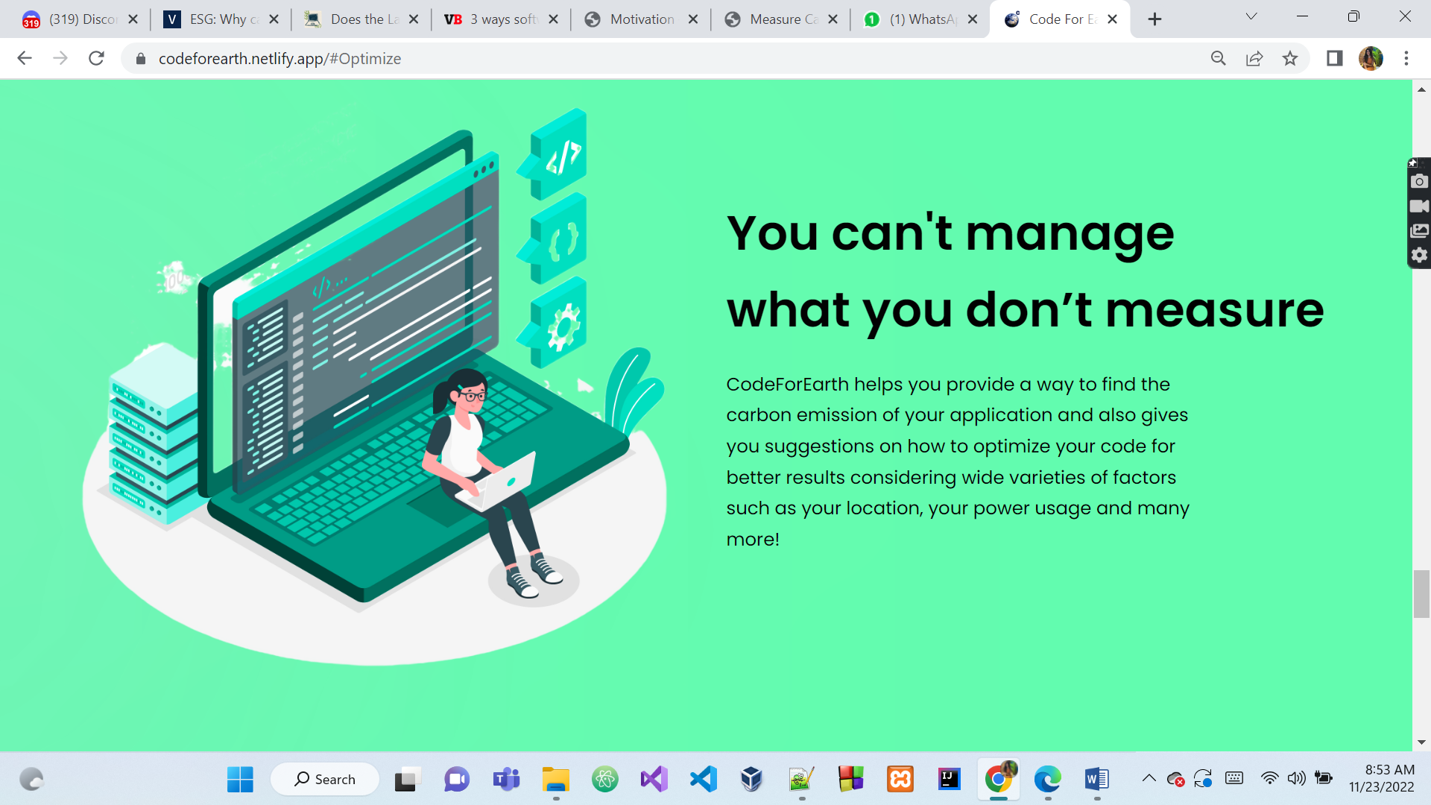



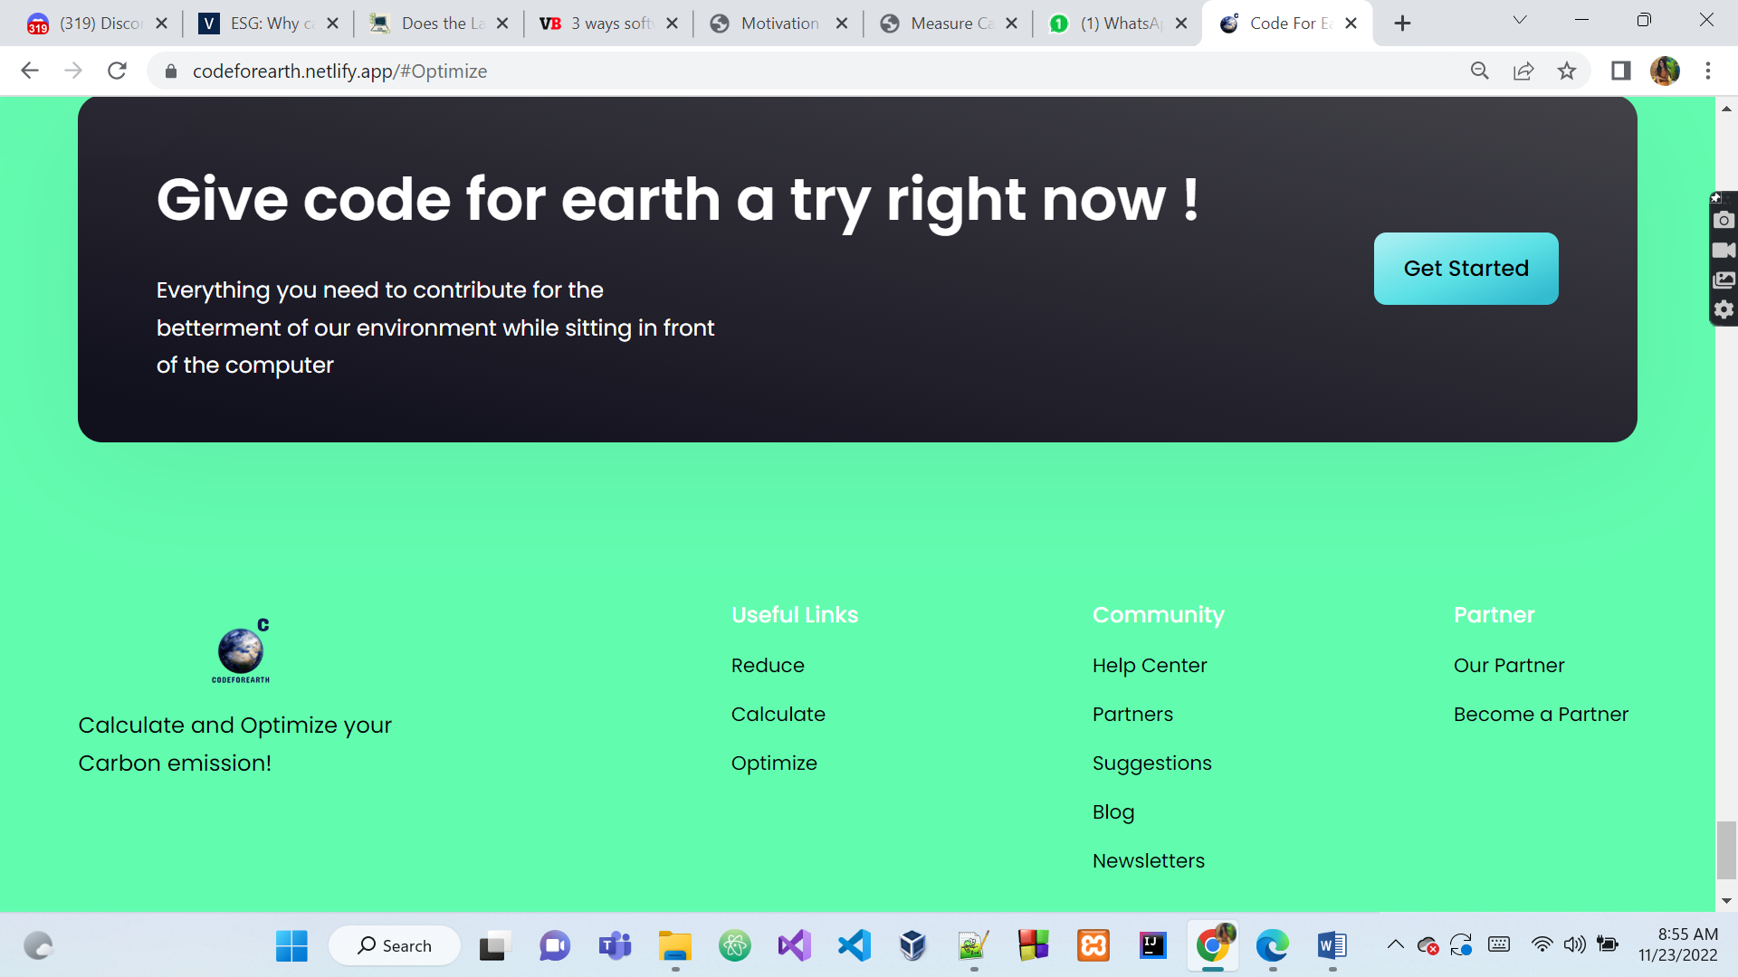

**Future scope and Conclusion**

It is evidently very necessary to keep working on our platform since there are many areas it can improve at. We will definitely continue progressing on our journey of codeforearth since we believe that it is the need of the hour to deal with this problem.

* We would like to propose a code parser which analyses the code block by block and provides the description of optimizable snippets of code in the entire codebase
* Our model would be based on the Peephole optimization principles of compiler design
* This is the next step of our journey with codeforearth

Artificial intelligence is becoming a more vital part of research and health. During our research we considered an approach that could provide a solution to our problem statement with the help of machine learning by trying to train a model that could help optimize code. But since technology advances by the minute, we’d have to re-train the model again and again to stay up to date with the latest technology trends. Today, AI has a significant carbon footprint, and if current market trends continue, it will soon be much worse. Hence, we opted not to choose this approach and went forward with the current one.